भारतमौसमविज्ञानविभाग |  | India Meteorological Department
Sunday,08th June 2025 (18 Jyeshtha 1947 Saka)
Summary of observations recorded at 0830 hours IST: The Northern Limit of Monsoon continues to pass through 17.0°N/55°E, 17.5°N/60°E, 18°N/65°E, 18.5°N/70°E, Mumbai, Ahilyanagar, Adilabad, Bhawanipatna, Puri, Sandhead Island, 23.5°N/89.5°E, Balurghat, 30°N/85°E. The upper air cyclonic circulation over northwest Rajasthan lay over Haryana & neighbourhood at 0.9 km above m. s. l. The upper air cyclonic circulation over northwest Uttar Pradesh lay over southeast Himachal Pradesh & adjoining Uttarakhand at 1.5 km above m. s. l. The upper air cyclonic circulation lay over central Pakistan & neighbourhood of today morning. It then persisted over the same region at 1.5 km above m. s. l. The trough in middle & upper tropospheric westerlies ran roughly along Long. 89°E to the north of Lat. 22°N. at 5.8 km above m. s. l. persisted. A fresh Western Disturbance as a trough in middle tropospheric westerlies with its axis at 5.8 km above m. s. l. ran roughly along Long. 54°E to the north of Lat. 25°N. An upper air cyclonic circulation lay over east Bangladesh & neighbourhood which extended upto 1.5 km above m. s. l. An upper air cyclonic circulation lay over southeast & adjoining eastcentral Bay of Bengal at 5.8 km above m. s. l. The western disturbance seen as a cyclonic circulation over Ladakh & adjoining Kashmir at 5.8 km above m. s. l. The upper air cyclonic circulation over northeast Assam & neighbourhood became less marked. The upper air cyclonic circulation over northeast Madhya Pradesh & neighbourhood became less marked. The trough from east Vidarbha to north interior Karnataka also became less marked.
Day temperatures were markedly above normal (> 5.1°C) at isolated places over west Uttar Pradesh, Himachal Pradesh and Jammu-Kashmir-Ladakh-Gilgit-Baltistan- Muzaffarabad. appreciably above normal (3.1°C to 5.0°C) at most places over Arunachal Pradesh; at few places over Assam & Meghalaya; at isolated places over sub Himalayan West Bengal & Sikkim, east Uttar Pradesh, west Rajasthan, east Madhya Pradesh, Saurashtra & Kutch, Tamil Nadu, Puducherry & Karaikal and Kerala & Mahe. above normal (1.6°C to 3.0°C) at many places over Nagaland, Manipur, Mizoram & Tripura, Bihar and Lakshadweep; at few places over coastal Andhra Pradesh & Yanam and coastal Karnataka; at isolated places over Gangetic West Bengal, Odisha, Haryana- Chandigarh-Delhi, west Madhya Pradesh, Telangana and Rayalaseema. near normal (-1.5°C to 1.5°C) at many places over Konkan & Goa, Vidarbha and north interior Karnataka; at most places over Jharkhand, Uttarakhand, Punjab, east Rajasthan, Gujarat region, Chhattisgarh and south interior Karnataka; at few places over Andaman & Nicobar Islands and Marathwada; at isolated places over Madhya Maharashtra. Yesterday, the highest maximum temperature of 45.3°C was reported at Jaisalmer (west Rajasthan).
The Southwest Monsoon has been subdued over Arunachal Pradesh, Assam & Meghalaya, Nagaland-Manipur-Mizoram-Tripura, Telangana, Tamil Nadu, coastal Karnataka, south interior Karnataka and Kerala.
Total 321 Station reported rainfall today. Total rainfall is 59.3 cm. Total 309 Station reported rainfall today whose normals are available. Total rainfall is 55.8 cm with normal station total is 188.1 cm.
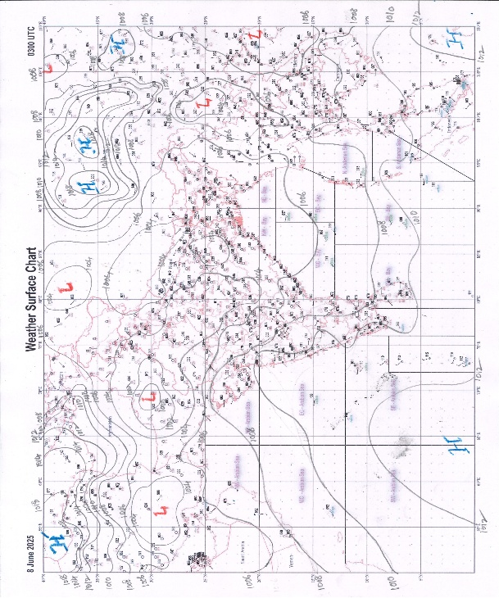 | 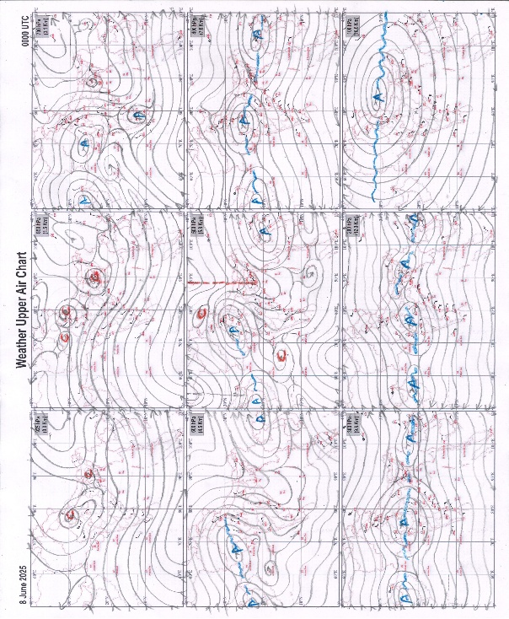
g.1. Analysed surface chart based on 03z observation | Fig.2. Analysed upper air chart based on 00z observation

Dr. S.D.Sanap
Scientist ‘D’
CR & S Office, Pune  Issued at 1245 hrs. IST |  | Weather Forecasting Division  CR&S, Pune

Indian regions | Realised rainfall (chief amount in cm during past 24 hrs):
East | a few places: Nagaland-Manipur-Mizoram-Tripura+  isolated places: Arunachal Pradesh, Assam & Meghalaya, West Bengal & Sikkim, Odisha, Jharkhand and Bihar  Dharmanagar / panisagar 9.9, Jiribam AWS 8.1, Rongo 4.6, Altuma 4.5, Kamakhyanagar 4.2, Jorhat 2.4, Jorhat AWS 2.3, Mathabhanga 2.1, Angul 1.8, Barapani 1.6, Lengpui 1.1, Dhalbhumgarh 1.0, Amtala 0.5, Bhalukpong, Darjeeling & Jhargram PTO 0.4 each, Tuting, Pasighat AP, Arki & Madhipura 0.3 each.
North | isolated places: Jammu-Kashmir and Ladakh  dry weather: Uttar Pradesh, Uttarakhand, Haryana, Punjab, Himachal Pradesh and Rajasthan  Poonch 0.4, Raj pura ARG 0.2.
Central | isolated places: west Madhya Pradesh, Vidarbha and Chhattisgarh  dry weather: east Madhya Pradesh  Tokapal 3.8, Darbha 2.0, Niwali 1.4, Dharampuri tappa & Jashpurnagar 1.1 each, Narmadapuram 0.9, Pusad 0.3, Digras 0.2, Kharangha 0.1.
Peninsula | a few places: Konkan & Goa+++ and coastal Karnataka  isolated places: Gujarat State, Madhya Maharashtra, Marathwada, coastal Andhra Pradesh, Telangana, Rayalaseema, Tamil Nadu, north interior Karnataka, south interior Karnataka◆ and Kerala  Uran 16.5, Mandangad 9.5, Babra 5.3, Washi 5.2, Anakapalle 4.9, Kadra 4.3, Colaba 4.1, Udgir IMD parttime 4.0, Phaltan 3.9, Rahuri 3.7, Vangoor 3.6, Renapur 3.3, Tekmal 3.2, Anakapalle (A) 3.1, Kanekal & K.m.koil 2.9 each, Allagadda 2.7, Lodhika 2.5, Nandyal 2.4, Khandala bavda & Kumarakam 2.3 each, Gadag PBO 2.2, Bhalki 2.1, Karkala 2.0, Rajkot & Humnabad 1.9 each, Andimadam taluk office & Alwaye PWD 1.5 each, Mangaluru AP 0.8, Medak 0.7, Kottayam 0.4, Khanvel & Ongole 0.3 each, Bhagamandala & Kibbanahalli 0.2 each, Kodaikanal 0.1.
Islands | most places: Andaman & Nicobar+  isolated places: Lakshadweep◆
Table 2. Forecast / warnings (distribution of rain / thundershowers) for 7 days (valid from time of origin upto 0830 hrs IST of next day)
Sr. No |  | Sub-division Name | Day 1 | Day 2 | Day 3 | Day 4 | Day 5 | Day 6 | Day 7 | Sr. No. | Sub-division Name | Day 1 | Day 2 | Day 3 | Day 4 | Day 5 | Day 6 | Day 7
 |  |  | 08 Jun | 09 Jun | 10 Jun | 11 Jun | 12 Jun | 13 Jun | 14 Jun |  |  | 08 Jun | 09 Jun | 10 Jun | 11 Jun | 12 Jun | 13 Jun | 14 Jun
 | 1 | Andaman Nicobar Islands | W +  | W  | W  | W  | W  | F | F | 19 | west Madhya Pradesh | I  | I  | I + | I + | I | I | I
 | 2 | Arunachal Pradesh | S | S | S  | F +  | F + | F + | F + | 20 | east Madhya Pradesh | I  | I | I + | I + | I | I | I
 | 3 | Assam-Meghalaya | I  | S  | S  | F +  | F +  | W + | W + | 21 | Gujarat region | I | I | I | I | I | I | I
 | 4 | Nagaland-Manipur-Mizoram-Tripura | S  | F  | F+ | F+ | F+ | F + | F | 22 | Saurashtra and Kutch | I | I | I | I | I | I | I
 | 5 | Sub Himalayan West Bengal/Sikkim | I | I | I | S | S | S | F | 23 | Konkan and Goa | S  | S  | I | I | S + | F+ | W+
 | 6 | Gangetic West Bengal | I + | I + | I | S  | F  | F | F | 24 | Madhya Maharashtra | I | I  | I  | I  | I  | S+ | S+
 | 7 | Odisha | I  + | I + | S  | S  | S  | S | S | 25 | Marathwada | I | I  | I  | I  | I  | S+ | F+
 | 8 | Jharkhand | I | I | S  | S  | S  | S | F | 26 | Vidarbha | I | I | I | I  | S  | S | I
 | 9 | Bihar | I | I | I | S  | F  | S | S | 27 | Chhattisgarh | I  | I | I  | I  | S  | S | S
 | 10 | east Uttar Pradesh | D | D + | D + | S  | I  | I  | S | 28 | Coastal Andhra Pradesh and Yanam | I+ | I + | S | S+ | F+ | S + | S +
 | 11 | west Uttar Pradesh | D | D + | D + | D + | I | I  | I | 29 | Telangana | S  | S  | S  | S  | S  | S | S
 | 12 | Uttarakhand | D | D | D | S  | F+ | F+ | F+ | 30 | Rayalaseema | I | S  | S | F+ | F+ | F + | F +
 | 13 | Haryana,Chandigarh and Delhi | D | D + | D + | D + | D | I  | I | 31 | Tamil Nadu, Puducherry and Karaikal | S  + | S  + | S+ | S+ | S+ | I + | I +
 | 14 | Punjab | D  + | D  + | D  + | D + | D | I | I  | 32 | Coastal Karnataka | S | F | F | W | W +  | W++  | W++ 
 | 15 | Himachal Pradesh | D | D | D | D | D | I | I | 33 | North interior Karnataka | S  | F +  | F  | F  | W +  | W ++ | W ++
 | 16 | Jammu-Kashmir and Ladakh | D + | D + | D + | D | D | I | I | 34 | South interior Karnataka | S  | F  | F  | F | W +  | W++ | W ++
 | 17 | west Rajasthan | D  + | D  + | D  + | D  + | D | D | D | 35 | Kerala and Mahe | S | F | W + | W + | W + | W ++ | W ++
 | 18 | east Rajasthan | D | D + | D + | D | D | D | I | 36 | Lakshadweep | S | S | F | W | W | W + | W +
Legends: D = DryI = IsolatedS = ScatteredF = Fairly widespreadW = Widespread #= heavy to very heavy rain at a few places with extremely heavy rain at isolated places +++= heavy rain at a few places with very heavy rain at Isolated places ++= heavy to very heavy rainfall @=Isolated exceptionally heavy rainfall + = heavy rain ●/*= rain or snow ♦ = very light rain ≡=fog= thunderstorm with lightning =Squall / Gusty / gale / strong wind ­ =cold wave/cold day += heat wave/warm night/hot and humid weathe r=Duststorm =ground frost = Hail

Fig. 4: Districtwise warnings for five days for Maharashtra State
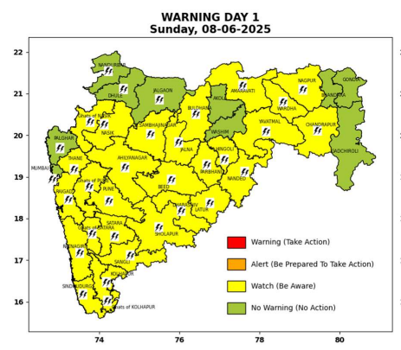 | 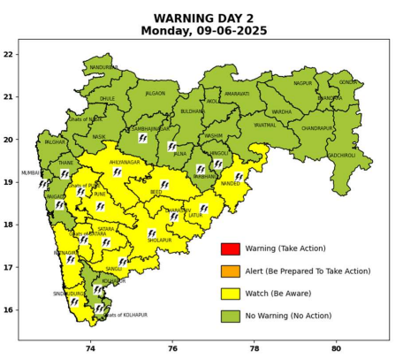 | 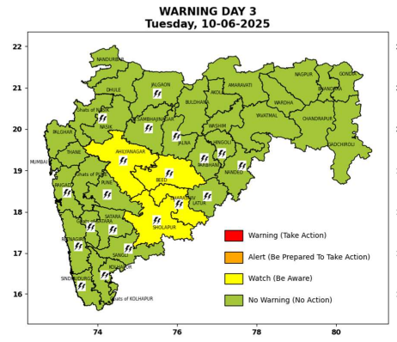 | 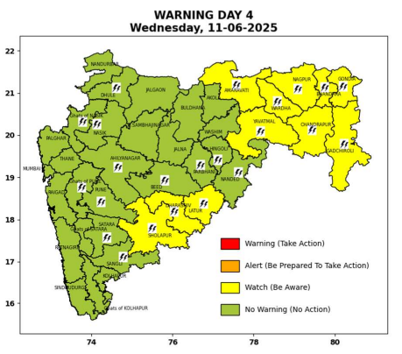 | 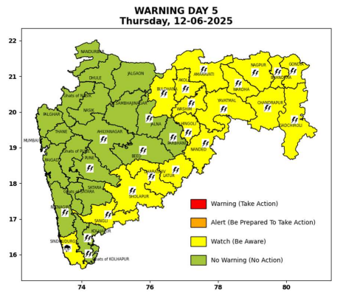

Pune, Lohegaon and Pashan observations at 0830 hrs. IST of Today
 | Temperature (°C) |  |  |  |  | Humidity (%) |  |  |  | Rainfall (mm)
 | Max.  past  24 hrs | Dep.  from  normal | Min.  past  24 hrs. | Dep.  from  normal | Dry  Bulb | At 0830 hrs. IST | Dep.  From  normal | At 1730  hrs. IST of y’day | Dep.  from  normal | Past  24 hrs. | Since  1st June | Dep.  from  normal
PNE | 29.2 | -5.1 | 22.6 | -0.8 | 25.8 | 78 | 5 | 69 | 11 | 5.0 | 38.1 | -6.4
PSN | 32.4 | - | 21.2 | - | 24.2 | 93 | - | 76 | - | 6.0 | 26.3 | -
LHG | 32.1 | -0.9 | 24.1 | 3.1 | 27.5 | 66 | -6.0 | 57 | 2 | 1.0 | 54.8 | 16.3

 |  |  |  |  |  |  | Local (Pune and neighbourhood) forecast
Max./Min. Temperature (°C) |  |  |  |  |  |  |  |  | Weather
Date | Pune | Pashan | Lohegaon | Chinchwad | Lavale | Magarpatta | NDA | Koregoan Park
08/06/25 | 32/22.6* | 32/21.2* | 34/24.1* | 31/23.3* | 30/-- | 33/24.0* | 31/21.2* | 32/24.0* | Partly cloudy sky becoming generally cloudy sky towards afternoon/evening. Thunderstorm with lightning, light rain very likely.
09/06/25 | 32/23 | 32/22 | 34/24 | 32/23 | 30/22 | 33/24 | 31/22 | 32/24 | Partly cloudy sky becoming generally cloudy sky towards afternoon/evening. Thunderstorm with lightning, light rain very likely.
10/06/25 | 33/23 | 33/22 | 35/24 | 33/23 | 31/22 | 34/24 | 32/22 | 33/24 | Partly cloudy sky becoming generally cloudy sky towards afternoon/evening. Thunderstorm with lightning, light rain very likely.
11/06/25 | 34/22 | 34/21 | 35/23 | 34/22 | 32/21 | 35/23 | 33/21 | 34/23 | Partly cloudy sky becoming generally cloudy sky towards afternoon/evening. Thunderstorm with lightning, light rain very likely.
12/06/25 | 34/23 | 34/22 | 35/24 | 34/23 | 32/22 | 35/24 | 33/22 | 34/24 | Partly cloudy sky becoming generally cloudy sky towards afternoon/evening. Thunderstorm with lightning, light rain likely.
13/06/25 | 33/22 | 33/21 | 34/23 | 33/22 | 31/21 | 34/23 | 32/21 | 33/23 | Partly cloudy sky becoming generally cloudy sky towards afternoon/evening. Thunderstorm with lightning, light rain likely.
14/06/25 | 32/22 | 32/21 | 33/23 | 33/22 | 30/21 | 33/23 | 31/21 | 32/23 | Partly cloudy sky becoming generally cloudy sky towards afternoon/evening. Thunderstorm with lightning, light to moderate rain likely.
Rainfall Distribution |  |  | Rainfall Categories | Rainfall (mm) |  | Cloud condition |  |  |  | Rainfall Intensity |  | Range
Widespread (W) | 76-100% |  | Very Light rain | Trace to 2.4 mm |  | Mainly clear sky |  | 1-2 oktas |  | Light Spell |  | 1 cm/hr
 |  |  | Light rain | 2.5 to 15.5 mm |  | Partly cloudy sky |  | 3-4 oktas |  | Moderate Spell |  | 1-2 cm/hr
Fairly Widespread (FW) | 51 – 75% |  | Moderate rain | 15.6 to 64.4 mm |  | Generally cloudy sky |  | 5-7 oktas |  | Intense Spell |  | 2-3 cm/hr
Scattered (S) | 26 – 50% |  | Heavy rain | 64.5 to 115.5 mm |  | Overcast |  | 8 oktas |  | Very Intense Spell |  | 3-5 cm/hr
isolated (I) | 1 – 25% |  | Very heavy rain | 115.6 to 204.4 mm |  |  |  |  |  | Extremely Intense Spell |  | 5-10 cm/hr
D (D) | No Rain |  | Extremely heavy rain | ≥ 204.5 mm |  |  |  |  |  | Cloudburst |  | > 10 cm/hr
Probability Terms in %: |  |  | Heavy snow | 6.5 to 11.5 cms water equivalent of rain
unlikely | < 25 |  | Very heavy snow | 11.6 to 20.4 cms water equivalent of rain
likely | between 25 50
very likely | between 51 75
most likely | >75
* = realized temperature
Mumbai (Colaba) |  |  |  | Nagpur (AP)
Date 2025 | T max °C | T min °C | Weather | T max °C | T min °C | Weather
08/06 | 33 | 25 | Partly cloudy sky with one or two spells of rain or thundershowers. | 41 | 28 | Rain or thundershowers would occur towards afternoon or evening. Thunderstorm with lightning.
09/06 | 32 | 25 | Generally cloudy sky with light rain. | 42 | 28 | Partly cloudy sky towards afternoon or evening.
10/06 | 33 | 26 | Generally cloudy sky with light rain. | 42 | 28 | Partly cloudy sky towards afternoon or evening.
11/06 | 33 | 26 | Generally cloudy sky with moderate rain | 41 | 27 | Rain or thundershowers accompanied with lightning & gusty winds(40-50kmph).
12/06 | 32 | 26 | Generally cloudy sky with moderate rain | 39 | 26 | Rain or thundershowers accompanied with lightning & gusty winds(40-50kmph).
13/06 | 32 | 26 | Rain. | 37 | 26 | Partly cloudy sky with possibility of rain or Thunderstorm.
14/06 | 31 | 25 | Rain. | 39 | 26 | Partly cloudy sky with possibility of rain or Thunderstorm.

